­­

**Xtag Design**

**Document**

Proof-of-Concept, Ergsense

**Date:** 2/19/19

**Revision:** 1.9*

**Author:** Justin Reina, Eric Ding, Tomm Aldridge

**Organization:** Ergsense LLC

**Customer:** Xylem Smart Water Solutions

**Summary:**

The Xtag proof of concept is presented for establishment and direction to achieve a product result.

**Notice:**

This document is intended for design establishment and production reference. The Xtag-POC establishes this path to product with physical hardware compliant for use as any sub-module for successful hardware operations. All contents of this file are compliant with the active Xtag Architecture Specification for operations.

(page left blank)

**Table of Contents**

1 System Description 4

1.1 Xtag Value Statement 4

1.2 Level Description 4

1.3 Module Description 4

2 System Architecture 5

2.1 Selection Considerations 6

3 Deliverables 7

4 Features 9

4.1 Sense 9

4.2 Operations 9

4.3 Analytics 9

4.5 Certification Compliance 9

5 Sensor Measurements 10

6 Ratings and Compliance 11

6.1 Ratings 11

6.2 Certifications 11

7 Hardware Functions 12

7.1 Power Sources 13

7.3 Power System Architecture 13

7.4 System Operation 14

7.5 Lifecycle 14

8 Power Budget 16

9 System Design 17

10 Mechanical Design 18

11 Electrical Design 20

12 Firmware Design 24

13 Components 29

14 Reference Hardware 31

15 POC Path to Product 32

16 Constraints 32

17 Opens 33

18 Appendix A – Click, Grove Feature Summary 34

References 35

Notes 35

# System Description

Multiple forms of Xtag description are used in POC development, summarized below.

## Xtag Value Statement

This section is left for further team elaboration, use of Commercial Specification and Architecture Specification is recommended for use. Alignment with the value statement of the i-ALERT 2 is targeted for Xtag development, with final designs formulated from test & user feedback results.

## Level Description

Three successive deliverable levels are presented for the Xtag-POC, Levels 1-3. Levels represent separate physical product solutions and are incremental revisions as well. The Xtag hardware changes in Levels 1-2, with software & functional changes performed in Level 3.

**Xtag Level Operations**

L1 - Core Functional Hardware for Level 1 (Xtag-B1)

L2 - Complete operational Xtag hardware

L3 - Complete Xtag POC Deliverable (HW/FW/SW/Demo)

**Xtag-POC Support**

The Xtag single board solution for Xtag-POC supports all features of L1, L2 and L3.

## Module Description

Three modules are established for the Xtag Solution, summarized below.

**Xtag Modules**

Xtag-B1 - Core Xtag module1

Xtag-B2 - 2nd bearing module

Xtag-M - Motor monitoring module

## Form Description

Two forms of Xtag are considered in Xtag-POC development, listed below.

**Xtag Forms**

Proof-of-Concept - Xtag-POC development by Ergsense [‘POC’, 1 board]

Production - Future product development [‘Solution’, 3 boards]

## POC Delivery Review

Ergsense POC work is tasked with delivery of the following –

**Ergsense Deliverable**

Spec - Specification of L1-L3

Proto - One working prototype supporting all features of levels 1-3, denoted ‘Xtag-POC’ or ‘Xtag-Board’

# System Architecture

The system is based around the Particle Argon Mesh for communications and platform, using an STM32F0 solution to satisfy all remaining IO. This solution is shown in Figure 1.

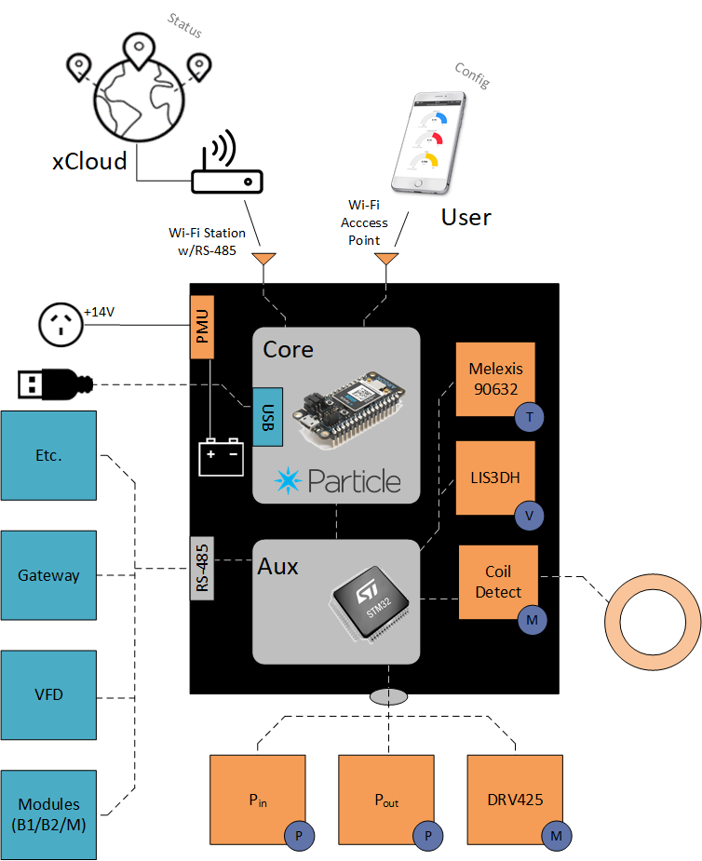

**Figure 1:** Xtag-Board system design

**Particle Feature Support**

* Processing & Control
* Wi-Fi
* Bluetooth
* Battery Charging & Use
* Flash memory
* Power Management (Wall, USB & Battery)

**STM32 Feature Support**

* Digital System IO
* Analog System IO
* RS-485

## Selection Considerations

Specific selections were performed in generation of the Xtag POC, optimizing concept delivery and maximizing product results output from this work, described below.

**Core Module – Particle Argon**

Particle is at a moment of market solidification and looking to establish IIOT presence, an opportunity of marketing and customer relations establishment for Xylem, in addition to platform considerations for subsequent product.

Xtag Value Points

* Combination of Wi-Fi + Bluetooth
* Bluetooth Mesh Support
* On-board Flash memory
* Particle Argon for POC aligns well with Particle A-Series module for product
* Excellent reference content & development support
* Novel marketing opportunities are present for all parties in this work

The Argon is selected for Xtag-B1 use to present Bluetooth & Wi-Fi, additionally featuring excellent battery management and use in its design. Placement of the Feather footprint also enables module intercommunications over Bluetooth Mesh, a unique feature to display in the Xtag POC. This footprint also presents the unique and low-cost flexibility for quick integration of unforeseen features or design needs.

**Aux Module – STM32F09**

The STM32F09 directly aligns with product Xtag recommendations, POC firmware releases will then directly align with product operations as well. The STM32F09 also supports all modules easily, preparing the POC for quick translation into product.

**Motor Sense - Magnetic Flux Sensor**

The magnetic flux sensor is of form factor to affix to motor with epoxy or directly onboard Xtag-M through the casing if possible. Two options are considered for evaluation by Xylem in the Xtag-POC:

* External Coil Detection (Induced Current Measurement)
* External Magnetic Flux IC Detection (TI DRV425)

**Temperature Sense – Melexis 90632**

Infrared temperature detection was selected for remote inspection considerations for mounting requirements.

**Module RS-485 Communications**

RS-485 is selected to support industrial system communications and simple extension to future inter-system comm (e.g. gateways, VFDs, sensors, etc.).

# Deliverables

## Xtag-Board

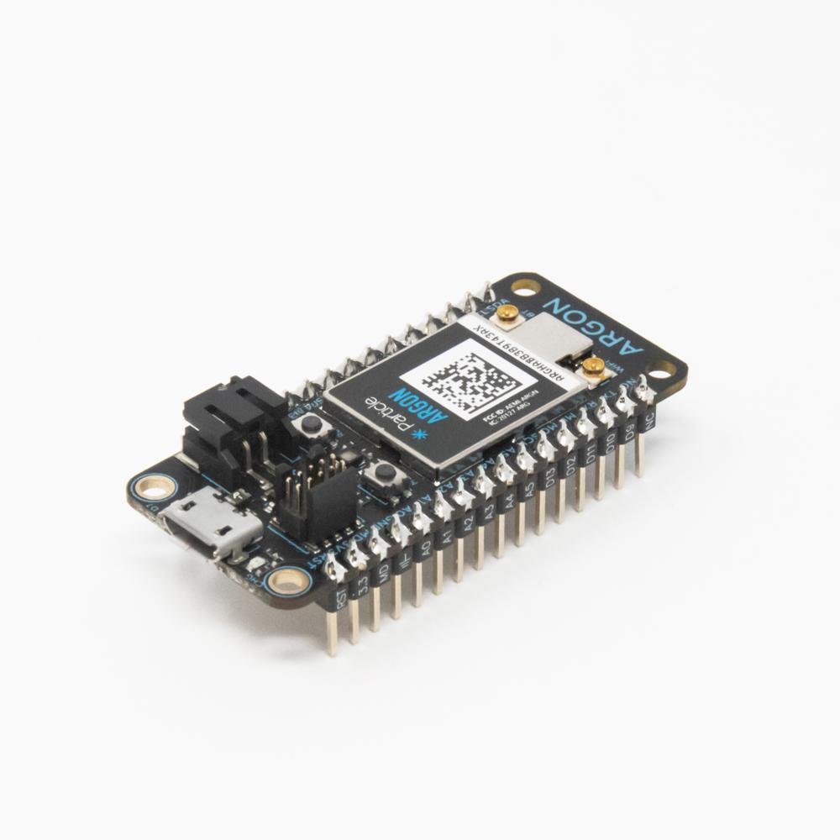

**Figure 2:** Particle Argon Mesh Unit

One functional Xtag board supporting all features of the Xtag module-based solution is provided. This board may be placed in as any of the Xtag modules, Xtag-B1, Xtag-B2 or Xtag-M and achieve successful operations with firmware adjustments.

**Particle Mesh**

The Xtag-Board uses a Particle Argon Mesh unit for processing, radio and battery, providing excellent support and coverage for the needed features. Particle features excellent reference and demo as well, maximizing the POC’s intent of delivering excellent and complete reference result.

## Design Coverage

The Xtag-Board can be inserted in for all modules B1, B2 & M, performing the needed operations for each. The final POC solution will then be (3) Xtag-Boards interconnected to achieve the operational Xtag POC result.

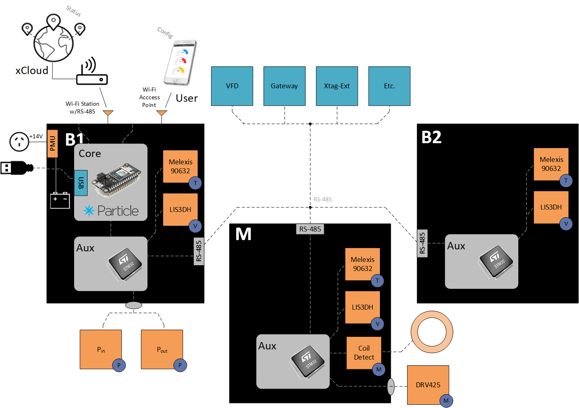

**Figure 3:** Xtag-Board Solution covering all modules

Note that Argon is used in Xtag-B1 and is optional for remaining modules. In this demonstration, the Argon uses Wi-Fi to connect to the XCloud for analytics & Bluetooth to the User device for configuration and status, with Xtag-B1 serving as RS-485 Master communicating with all other devices.

If wireless module communication is desired for the POC, insert the Argon to all units and instrument Bluetooth Mesh communications.

## Xtag-Ext

The Xtag-Ext connects over the internal RS-485 interface, providing the following features –

* SD Card
* Internal Flash Memory
* MikroElectronika Click Support ([ref](https://www.digikey.com/en/product-highlight/m/mikroelektronika/mikrobus-click-boards))
* Seeed Grove Support ([ref](http://wiki.seeedstudio.com/Grove_System/))

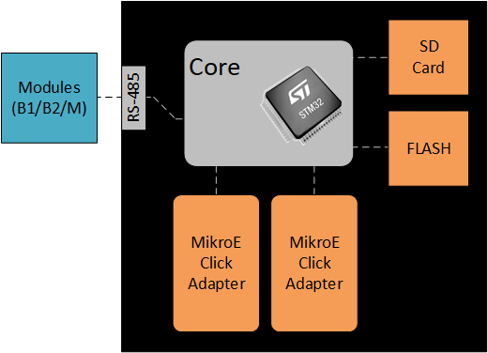

Figure 4: Xtag-Ext board description

Click Interface

The MikroElectronika Click interface supports over 500 existing Click units, including the following –

* Sense – Pressure, Light, Chemical
* Control – DC motor, PWM motor
* Radio – LoRa, Wi-Fi, BLE, Custom
* Comm – USB, LAN, CAN

See Appendix A – Click, Grove Feature Summary for a larger listing of supported Click devices.

Grove Interface

The Seeed Grove interface supports over 200 additional sensor modules using the simple I2C powered interface, with excellent reference and quick result of working demonstration.

Future Works Coverage

* Future Dev - The Xtag-Board and Xtag-Ext solution prepares Xylem well for future development and research. This selection covers a wide feature site with quick interconnectability over RS-485, Wi-Fi and Bluetooth.
* Flexibility - The Xtag-Board’s use of the Feather footprint with 100-mil pluggable connection make the Xtag-POC very flexible, allowing components underneath the feather, and providing flexibility to alternative feather models (e.g. ESP32)
* Extensibility - Integration of the RS-485 device interface and Click module interface equips the Xtag architecture with quick and low-cost methods for future development when needed.

# Features

## Sense

* Pump Monitoring
  + Nominal sample rate of 1 Hz (100-300ms target)
* Asset Monitoring
* Real-time Interface
* Low-battery notification

**Measurements for Consideration**

* Kurtosis

## Operations

* Perform & schedule routine
* Config initial storage
* Configurable Alarms
* Data points every hour for last 30 days provided (170-300 day storage)

## Analytics

* Statistics
* Reports (30/60 day)

## Interface

* Mobile Interface
* Web Interface
* Interfaces
  + PoC - Wi-Fi, Bluetooth, RS-485
  + Local – LEDs, 1-2 buttons
  + Prospect - LAN, Serial
* RS-485 System Interface (M)
  + VFD (S3)
  + Xtag-B2 (S)
  + Xtag-M (S)
  + DB9 (S) [DNP]
* RS-485 Gateway Interface (Follower)
  + Gateway (M)
* VFD Interface (RS-485)
* Gateway Connection (Wi-Fi)
  + RS-485 hardware interface provided (RS-485 Click Module, Follower)

## Certification Compliance

* Casing and all interface components are IP65 compliant (e.g. power supply connector, etc.)

## Extensibility

The Xtag POC includes a selection of features to promote extensibility for Xylem use –

Features

* Additional module expansion by RS-485, Wi-Fi & BLE-Mesh
* Xtag-Board and Xtag-Ext expansion support
* MikroElectronika Click Interface support (2 modules, Xtag-Ext design)
* Seeed Grove interface support (connection provided to Xtag_Board, allowing use for all modules)

Notes

* The module expansion interface supports connected batteries, enabling quick extension of device battery life

# Sensor Measurements

1. Bearing #1 Temperature (Infrared)
2. Bearing #1 Vibration (IC)
3. Bearing #1 Orientation (IC)
4. Bearing #2 Temperature (Infrared)
5. Bearing #2 Vibration (IC)
6. Motor Temperature (Infrared)
7. Motor Vibration (IC)
8. Motor Magnetic Flux (2) (B-Series)
   * Option I – Fluxgate2 (On-board)
   * Option II – External Sense (DNP w/Plan)

**Notes**

* + Explanation & description. Add note of value for product of standard interface
  + Tomm will assist in selection
  + 4-wire interface is target

1. Pump Pressure (2) (4-20mA)
   * Inlet Pressure
   * Outlet Pressure

# Ratings and Compliance

## Ratings

* A discussion of IP65 is provided
* Bluetooth has a working typical range of 30m (100 ft)

## Certifications

* A discussion of communication certifications compliance is provided

## Electrical

* A discussion of external electrical signal isolation and safety is provided

**Current Limit Protection**

Current limitations are imposed to both Xtag rails for safe operation.

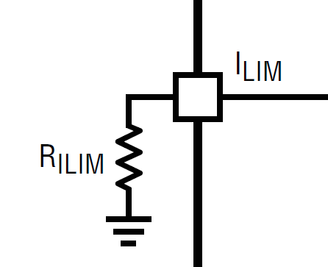

**Figure 5:** VDD Current Limit Resistor

* VDD (3.3V) – Regulator current limited supply (LT3663)
* VS (12V) – Inline Current fuses (MAX14626)

The VDD supply uses a limit resistor for configuration (RILIM), and inline fuses for each sensor connection, traditional current loop protection units.

## Mechanical

* For IP65 compliance, etc.

## Thermal

85 **°**C – Operation <For Team Confirmation>

100 **°C – Storage** <For Team Confirmation>

## For Consideration

* IP67, IP68
* C1D1
* Zone0

# Hardware Functions

**Xtag**

* Monitor Local Sensors
  + Vibration
  + Temperature
* Monitor External Sensors
  + Pump Pressure
  + B2/M Report
* Communications
  + Bluetooth
  + Wi-Fi
  + RS-485 Master
* Local Interface
  + LEDs
  + Buttons
* Data Storage
  + SD-Card
  + Flash
* Power Management
  + Battery (Lithium-Polymer)
  + Motor Harvest (Option)
  + Wall Supply (5.5/2.1mm jack, USB)
  + USB Supply (USB B Mini)

**Xtag-B2**

* Monitor Local Sensors
  + Vibration
  + Temperature
* Communications
  + RS-485 Follower

**Xtag-M**

* Monitor Local Sensors
  + Vibration
  + Temperature
  + Flux
* Communications
  + RS-485 Follower

**Pressure Sensors**

* (2) External Screw-in sensors with analog signal output

## Power Sources

**Core**

* Wall Power (5.1mm/2.5mm Jack IP65)
* USB B Micro (Argon connection)
* Battery (Argon connection)
* Wire-to-Board (Wire-to-Board & Header)

**Options**

* Inductive Energy-Harvesting (Motor)
  + Not sure if needed or valuable
  + Variable speed applications may introduce risk
  + Left for future prospect
* Future Module Supply (Xtag-Ext connect
  + Power sources (e.g. energy harvesting)
  + Power storage (e.g. larger remote batteries)

**Features**

* Separate supplies (VS=12V, VDD=3.3V)
* Current limited operation (VDD configurable, VS selectable)
* Open & Short Load support (for 4-20mA current loop inputs)

## Power Modes

There are two modes of operation for system operation –

1. Wall Power – Power adapter connection
   * Battery Charge5: On
   * Battery Boost5: Off
   * Power Rails: Wall Supplied
2. Battery Power – Internal battery connection
   * Battery Charge: Off
   * Battery Boost: On
   * Power Rails: Battery Supplied

## Power System Architecture

The Xtag emphasis simplicity in the Xtag-POC design, featuring traditional market solutions with common component selection. The Argon in POC design presented a unique opportunity in this, with support for battery use and 3.3V rail generation on-board, using common product-compliant components.

From this point VDD and VBATT are sourced from the Argon, with an external Boot regulator generating VS. External power connection (8-30V) is also provided to Xtag, enabling the Argon & VS power support delivering a simple and complete Xtag result.

## System Operation

The following system operating modes are defined for Xtag operation.

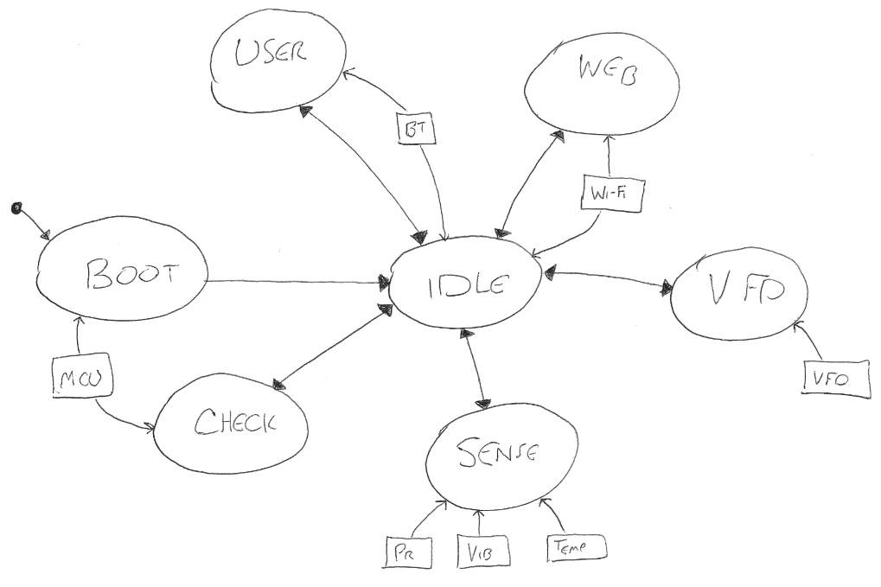

**Figure 6:** System operating modes

**Operating Modes**

Boot [MB] – Boot from cold

Idle-BT [MI] – Device is connected to Bluetooth and idle

Idle-Away [MA] – Device is disconnected from Bluetooth and idle

Sense [MS] – Measure sensed values

User Report [MU] – Provide one report over Bluetooth

Check [MC] – Check system state & alarms

VFD [MV] – Report reference values to VFD

Web [MW] – Xylem Cloud interaction and report

## Lifecycle

Boot -> Idle:

MS – 5 minutes (12 per hr)

MC – 60 minutes (1 per hr)

MU – 360 minutes (4 per day)

MW – Unspecified ()

<open> Definition of the activity in each mode needs established.

## Sense Mode (MS)

On scheduled measurement the reported values will be measured once.

Vibration (B1)

Measurement values at 1.1 kHz will be sampled in 3 dimensions

Temperature (B1)

Temperature will be measured through the case window using infrared detection

Pressure (B1)

<open>

Vibration (B2)

<open>

Temperature (B2)

<open>

Vibration (M)

<open>

Temperature (M)

<open>

Flux (M)

<open>

## User Report Mode (MU)

On user request the system will connect and perform one report of new system data and measured values to one device.

## Check Mode (MC)

On scheduled occurrence the system will check on operating state and report of any detected alarms or notifications.

# Power Budget

The following components are considered for the Xtag-POC power forecast at this time.

**System Components**



The following considerations were used for this specification:

* Particle Argon – Base on Feather ESP32 max specification
* STM32 – Datasheet max spec
* LEDs – All on at max
* SN65 – Quiescent Spec
* MLX – Operating Spec
* LIS – Operating Spec
* DRV – Operating Spec
* Current Loops – Both at max (20mA) with margin

**Vs Specification**

12V @ 250mA is used as peak current for inductor specifications.

**VDD Specification**

3.3V @ 1.2A is used for system design at this time.

# System Design

The following description of Xtag operation sets the flow and architecture of following sub-components, e.g. electrical subsystems, mechanical subsystems and analytic services provided.

## System Power Control

The Xtag will have the following awareness and control of its system power –

**Power Awareness**

* Input connection status (Jack, Wire, Batt & USB)
* Battery state & remaining capacity

**Power Control**

* System control on power state
* External notification of state and change
* Internal storage of power history

The system will be able to determine if valid power remains, taking action when this adjustable boundary is surpassed. The system will enter a power mode of ‘Idle’ with this event occurs and remain until a valid change of power input is observed (e.g. fresh battery, wall power, etc.).

**Report**

The Xtag presents power level summary & report over each system communication interfaces and stores in log to memory.

**Notifications**

The Xtag presents configurable options for power notification, listed below.

* Local (LED4, Audible)
* Web (XCloud)
* Email (Single, Group)
* Mobile (Review, Alert)

**Configuration**

To optimize battery usage, subsystem power thresholds are observed.

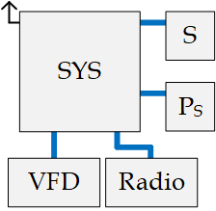

**Figure 7:** Power modules for configuration

Power Subsystems

* System (SYS)
* Sense (S)
* Pressure Sense (Ps)
* VFD (V)
* Radio (R)

Levels are configured and stored in percentage (0-100%), with a default value of “-1%” indicating system (SYS) value use. Once triggered, systems will remain in ‘Idle’ status until power or configuration changes are observed, e.g. wall power is plugged in or the user config is changed.

# Mechanical Design

The following content is subject to further review and not complete at this time.

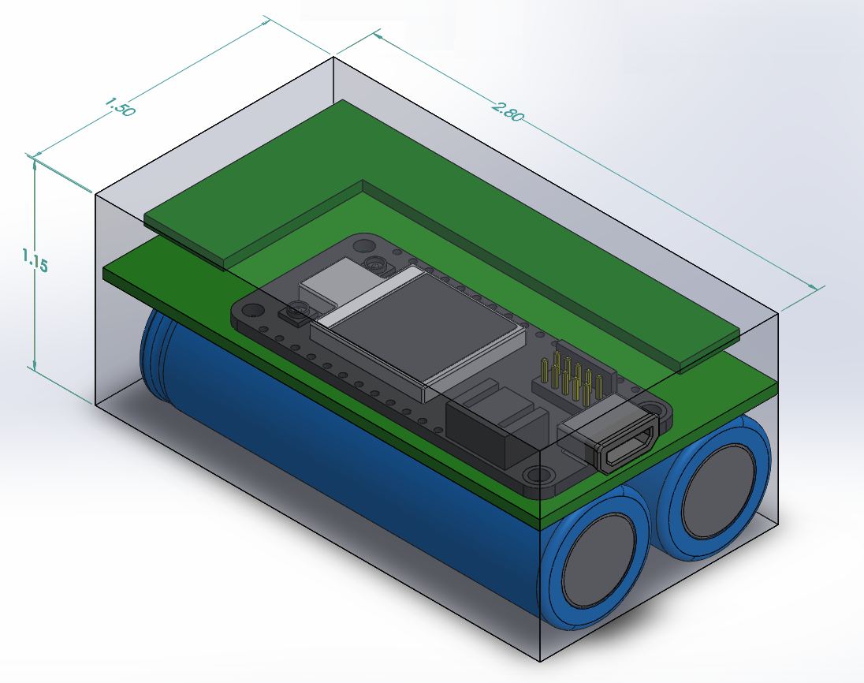

**Figure 8:** Xtag-B1 min dimensions

**Dimensions Specification**

Rough equivalence to [i-ALERT 2](https://www.i-alert.com/products/#sensor):

* (W): 1.50” x (L): 2.25” x (H): 1.00”

**Existing Design**

Preliminary model:

* (W): 1.50” x (L): 2.80” x (H): 1.15”
* (W): +0” x (L): +0.55” x (H): +0.15”

Margins are integrated at this point of development, summarized below.

**POC-Product Differences**

* Battery Selection (1) PKCell 803860 Lithium-Polymer Cell, 3.7V @ 2000mAh w/PCM
* Radio Selection The Particle Argon module is selected to provide WLAN & BT5 radio support for POC

with lowest cost to successful working unit and support for inter-module comm

* Connector Selection IP65 compliant connectors are selected to approximate form factor considerations for

compliance in dimension

* <difference listing expanded on notice>

**Existing Uncertainties**

* Power Budget <- Smaller battery (H)
* Board Density <- Smaller dims (W, L)
* Board Size <- Smaller dims (W, L)

With these items resolved the specification is expected while meeting all device specifications.

**Design Specifications**

* Pressure sensors use the G 3/8” NPT input thread (Lowara e-NSC)
* All Xtag units are affixed to the pump frame directly with epoxy

**Material Specification**

* Stainless steel is used for case construction featuring <tbd> bolt selection, with high impact polycarbonate used for all external plastic components

**Device Connection:**

Multiple device connections are observed:

* Magnet
* Screw - Drill & Tap
* Epoxy

Selection

The magnet connection is minimally invasive and easily adjusted, and selected at this time. Here is a candidate under consideration –

K&J (½” x ⅛”):

Dimensions: ½" dia. x ⅛" thick

Tolerances: ±0.004" x ±0.004"

Material: NdFeB, Grade N42SH

Plating/Coating: Ni-Cu-Ni (Nickel)

Magnetization Direction: Axial (Poles on Flat Ends)

Weight: 0.106 oz. (3.02 g)

Pull Force, Case 1: 6.44 lbs

Pull Force, Case 2: 16.00 lbs

Surface Field: 2952 Gauss

Max Operating Temp: 302**°**F (150**°**C)

Brmax: 13,200 Gauss

BHmax: 42 MGOe

A steel cup is considered for installation fixture, which contains the field and provides more holding force than a bare magnet:

Magnet:

NCS82

Nickel-plated Steel Cup

Holds ½" x ⅛" Disc Magnet

5/8" O.D. x ¼" thick overall

**External Component:**

* Xtag power is provided to the Xtag-B1 module and shared with Xtag-B2 & Xtag-M through cable connections
* Xtag-B1 is powered through an IP65 compliant interface
* Motor Flux Sensing is currently achieved through onboard fluxgate sensor
  + Pending review & confirmation of operations
  + External coil sensor is alternative option (left as DNP to existing POC)

# Electrical Design

## Power System Architecture

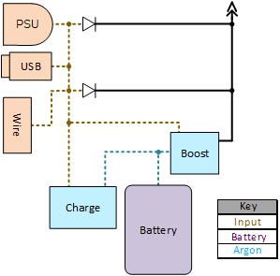

**Figure 9:** Power System Architecture Summary

The Xtag features the following power sources, illustrated in

Figure 9 -

**Power Sources**

1. Internal Battery (‘B’)
2. Wall Supply (‘PSU’)
3. Wire (‘W’)

**Power Rails**

* Vin – External Power (+8-30V)
* VBAT – Internal Battery (+3.7V)
* Vcc – Xtag Power Supply (+3.3V)
* Vs – Vsense (+12V)

The boost is enabled only when external power is disconnected,

providing safe interoperation of Xtag power sources at all times.

**Vs Power Flow**

VS is provided from all interfaces and power supplies:

* VWall 🡪 Direct
* VUSB 🡪 Boost
* VBatt 🡪 Boost

**VDD Power Flow**

VDD is provided from all sources through direct use of the 3.3V LDO.

* VWall 🡪 LDO
* VUSB 🡪 LDO
* VBatt 🡪 LDO

**VBATT Power Flow**

VBATT is charged by wall power, operating at 7.2V nominal in support of (2) series battery cells.



## Pressure Sense Topology

An instrumentation amplifier was selected for current loop measurement of the pressure sensor inputs using the Texas Instruments INA826. This architecture features +30V input supply to the sensor followed by a tail resistor for current measurement, shown below for reference -

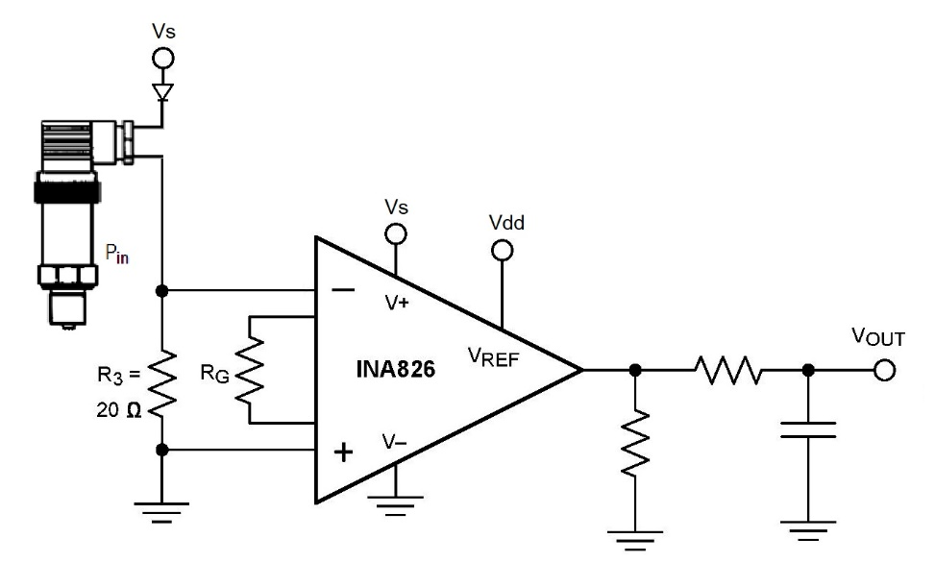

**Figure 10:** Selected Pressure Sense Topology

**Reference Units**

* Endress+Hauser Inc. Cerabar PMP21 ([ref](https://www.us.endress.com/en/field-instruments-overview/pressure/Absolute-gauge-Cerabar-PMP21))
* TI INA 826 Datasheet Fig. 63 ([ref](http://www.ti.com/lit/gpn/ina826))

**Design Selection**

* TI - E2E Support Discussion ([ref](https://e2e.ti.com/support/amplifiers/f/14/t/727930))
* Acromag – Intro to Two-Wire Transmitters ([ref](https://www.google.com/url?sa=t&rct=j&q=&esrc=s&source=web&cd=24&ved=2ahUKEwjSzsXanc_dAhVn44MKHfcECxAQFjAXegQIABAC&url=https%3A%2F%2Fwww.acromag.com%2Fsites%2Fdefault%2Ffiles%2FAcromag_Intro_TwoWire_Transmitters_4_20mA_Current_Loop_904A.pdf&usg=AOvVaw0aPk1Adb51joW0XmXrSmD9))
* NI - Setup for the 4 to 20 mA Current Loop ([ref](http://www.ni.com/white-paper/6940/en/))
* DataQ – 4-20 mA Measurements ([ref](https://www.dataq.com/blog/data-acquisition/4-20-ma-current-loop-measurements/))

**Input Protection**

* Terminal short – Current loop protection units ([MAX14626](http://www.ti.com/product/LM2673))
  + The selected receiver of the SN65HVD1x is also designed against this
* Over voltage – Input Diodes (e.g. D12)
* Floating ground – Digital Signal Isolation ([ref](https://www.google.com/url?sa=t&rct=j&q=&esrc=s&source=web&cd=4&ved=2ahUKEwjR2N3lk5TeAhWBOn0KHX9QDewQFjADegQIBxAC&url=http%3A%2F%2Fwww.ti.com%2Flit%2Fug%2Ftidu804%2Ftidu804.pdf&usg=AOvVaw2FvCJAl2ZsKBGus1GrWG6A)/[ref](https://www.google.com/url?sa=t&rct=j&q=&esrc=s&source=web&cd=3&ved=2ahUKEwjR2N3lk5TeAhWBOn0KHX9QDewQFjACegQICBAC&url=http%3A%2F%2Fwww.ti.com%2Flit%2Fwp%2Fslyy112%2Fslyy112.pdf&usg=AOvVaw0xarykps25WeIqWVtsP8nv)) or Loop Powered Isolation ([ref](http://www.ti.com/tool/TIDA-00167))
  + Both have high investment cost for design & validation
  + Inline sensor module is recommended, connecting VCC from both power domains
* Open or Idle Connection Status - SN65HVD1x design

**Notes**

* Current limit protection is integrated inline for all 4-20mA sensors connections
  + “Xtag still functions when the current loop input terminals are shorted”
* Additional current loop inputs (e.g. flow sensors) may be integrated quickly with analog multiplexor design
* Independent transformers (INA826) per sensor have been observed in prior Xylem work

## Variable-Frequency Drive

Physical interface to be established, command description provided by Xylem and validation not required.

## Communications

**Design Targets**

* Buffered IO for all communication signal connections (including power)
  + High priority for connection safety
* Gateway RS-485 connections can be bi-directional (e.g. Phytec phyGATE)

## POC Development Options

One consideration for the Particle Argon selection was its support of the [Adafruit FeatherWing architecture](https://www.adafruit.com/category/814). The FeatherWing architecture easily supports a large listing of new plug-in devices, quickly extending Xtag-POC use -

* [Ethernet](https://www.adafruit.com/product/3201)
* [SD-Card](https://www.adafruit.com/product/2922)
* [Proto](https://www.adafruit.com/product/2884)
* [Relay](https://www.adafruit.com/product/2923)
* [Power Relay](https://www.adafruit.com/product/3191)
* [LoRa](https://www.adafruit.com/product/3231)
* [TFT](https://www.adafruit.com/product/3315)
* [OLED](https://www.adafruit.com/product/2900)
* [Audio](https://www.adafruit.com/product/3357)
* [GPS](https://www.adafruit.com/product/3133)
* [Speakers](https://www.adafruit.com/product/3436)
* [DC Motors](https://www.adafruit.com/product/2927)
* [Servo Motors](https://www.adafruit.com/product/2928)
* [GPIO Breakout](https://www.adafruit.com/product/2926)
* [RTC](https://www.adafruit.com/product/3028)

## ADC Signal Levels

The following signals are connected to the STM32 processor on the Base board unit –

**Analog Signals:**

* VOUT: 0.00V1 [0000] – ADC_IN0 (PA0)
* MSENSE: 1.65V [2047] – ADC_IN1 (PA1)
* VIN_D: 1.15V [1422] - ADC_IN2 (PA2) 12.2 V (48.1k/4.99k divider)
* VDD_D: 2.75V [3411] – ADC_IN3 (PA3) 3.3 V (1k/4.99k divider)
* P_IN: 0.00V2 [0000]– ADC_IN8 (PB0)
* P_OUT: 0.00V2 [0000]– ADC_IN9 (PB1)
* VBUS_D: 2.77V [3436] – ADC_IN14 (PC4) 5.0 V (4.02k/4.99k divider)
* VS_D: 2.74V [3394] – ADC_IN15 (PC5) 12.0 V (16.9k/4.99k divider)

Notes:

1 – Value is pending confirmation

2 – When input signal from pressure is connected, else value is unknown

## Vibration Measurement

The Xtag measures up to 15 harmonics on the motor installation. For the target motor of 1800 rpm this yields a bandwidth of 450Hz, where a sample rate of 1kHz is used to record acceleration for vibration calculation.

## Misc. Rules

**Wiring Insulation**

* Wires are insulated when possible to mitigate antenna effects when possible
  + Large sources of noise observed in target use cases

Insulated wiring is recommended for pressure sensors to eliminate injected current signals.

# Firmware Design

## System Architecture

The Xtag_Board contains two control units, the STM32 ‘Core’ control with the Particle Argon for ‘Communications’:

**Control Units:**

1. STM32 – Core Control & Device Operations

FreeRTOS (v9.0.0) is selected as generated through STM32CubeMX V1 (v5.0.0), programmed through SWD with J5 of the Base unit.

1. Argon – Wireless communications, memory storage & math processing

The following architectures have been identified:

1. ICSP: MCU direct programming (SWD)
2. Arduino: Wrapper interface for operations (USB)
3. Workbench: Particle ecosystem (USB)

Bluetooth has not been released yet for the Argon Feather solution and from this ICSP has been selected allowing Bluetooth operations. Platform selections or Particle OS releases may alter this selection upcoming.

**STM32 Operating System:**

The STM32 operating system features a non-preemptive multi-threaded application:

1. Sense - Thread to sample sensor values
2. Bluetooth - Thread to interface Argon for Bluetooth communications
3. System - Thread to monitor and control system operation
4. Demo - Thread to present development demo operations (e.g. ADC, LIS3DH, etc.) if needed

Other threads may be present (e.g. Wi-Fi, USB, etc.) serving as placeholders for future operations if needed. All components of the firmware are fresh at this time and serve as a starting point, subject to revision or replacement when needed to establish the final successful system.

**Development:**

1. STM32
   1. IDE: TrueSTUDIO v9
   2. ICSP: ST-Link/V2
2. Argon
   1. IDE: SEGGER Nordic Studio
      1. Particle Workbench and Particle WebOS are also available
   2. ICSP: Segger J-Link EDU
      1. *USB is used for Workbench/WebOS/Arduino

## Sample Timing

The following timing specifications are observed for Xtag operation –

**Sensor Sample Specification:**

* Pressure 10 S/s
* Temperature 1 S/s
* Magnetic Flux 10 kS/s
* Vibration 10 kS/s

## TestApp Communications

TestApp communications follow the asynchronous half-duplex protocol listed below -

**Command Structure**

This channel shall follow the [XML syntax standard](https://www.w3schools.com/xml/el_notation.asp). The channel features a stream of Messages (‘<*MessageID*>’):

**Messages:**

* Information (“*<I>*”)
* Hello (“*<H>*”)
* Vibration (“<V>”)
* SensorData (“*<D>*”)
* SensorSnap (“*<N>*”)
* SystemState (“*<S>*”)
* SnapRequest (“*<R>*”)

**Fields:**

* Xtag UUID (“<U>”)
* Time (“<T>”)

**Xtag Commands**

All commands include the UUID & Timestamp as 1st & 2nd fields, respectively.

* Information (“<I>”) – Sharing a string of information

“<I>Xtag initialization complete.</I>” (A string for communication or display)

* System Status (“<S>”)

“<S><BT>1</S>” (System state)

* Hello (“<H>”) – Activity and status indicator

“<H>0123</H>” (U32 timestamp of activity)

* SensorData (“<D>”) – Listing of current value for all sensors

“<D><T>0123<S1>0000<S2>0000…</D>” (N=13 sensors, U16 hex values)

S1 – MSense [ADC Value]

S2 – PIN [ADC Value]

S3 – POUT [ADC Value]

S4 - VOUT [ADC Value]

S5 - VUSB [V]

S6 - VDD [V]

S7 - VS [V]

S8 – VIN [V]

S9 – ACCELX [mg]

S10 – ACCELY [mg]

S11 – ACCELZ [mg]

S12 – VIBRATION [*]

S13 – TAMBIENT [°C÷100]

S14 – TOBJECT [°C÷100]

* Vibration (“<V>”) – FFT Display of active vibration activity [Hz, m/s2]

“<V><F>100.1<A>1.34<F>110.2<A>4.56<F>120.2<A>7.89…</V>” (A{F} in sequence order)

Scales

Units for each sensor are assumed standard unless otherwise noted.

* VUSB­­/VIN/VS (V/100)
* VDD – (V/10,000)
* SensorSnap (“<N>”) – Time series snapshot of specified sensor

Time interface description is known and the values sent U16-CSV in Hex

e.g. “<N>”*0000,1111,2222</N>*”

* SystemState (“<S>”) – Listing of the current system state

(open for description)

**TestApp Commands**

* SnapRequest (“<B>”) – Request for snapshot of selected sensor

(open for description)

Data & System State are sent periodically, the Sensor snap is sent in response to TestApp request. This interface will also be extended to support master-follower architectures later, including BLE and SPI.

## Inter-processor Communications

The STM32 and Argon communicate over a 4-wire SPI interface with the STM32 as master. Power is not a factor at this stage of development and this communication channel is always active while powered. The system uses the following convention –

**General Notes**

* STM polls for activity every 125ms with ‘Hello’
* STM transmits messages as needed

**Message Form** (one-byte fields unless noted)

<Header ID><Payload Size><Payload[N]><Message><Checksum><EOP>

Header ID: Name of the message [1B]

Payload Size: Number of bytes ‘N’ in the payload’ [1B]

Payload: Payload of message or response [NB]

Message: Meta data (e.g. Argon activity request) [3B]

*<N remaining> <next ID> <next payload size>

Checksum: U8 sum from header through message [1B]

EOP: End-of-Packet (“</EOP>”) [6B]

Total: [(12+N) B]

The STM will share a message, e.g. “Hello”, and then the Argon will provide a response in the next message of the following form -

Name Header ID Payload Size

* **Hello** (‘0x10’) [1 Byte]
* **Hello Response** (‘0x11’) [A Bytes]
* **BLE-Config** (‘0x12’) [B Bytes]
* **BLE-Config Response** (‘0x13’) [1 Byte]
* **BLE-Data** (‘0x14’) [C Byte]
* **BLE-Data Response** (‘0x15’) [1 Byte]
* **BLE-Stat** (‘0x16’) [1 Byte]
* **BLE-Stat Response** (‘0x17’) [D Bytes]
* **BLE-Message-Send** (‘0x18’) [E Bytes]
* **BLE-Message-Send Response** (‘0x19’) [1 Byte]
* **BLE-Message-Retrieve** (‘0x18’) [F Bytes]
* **Question-Retrieve** (‘0x19’) [G Bytes]
* **Question-Response**  (‘0x1A’) [J Bytes]
* **BLE-Last Message Stat** (‘0x1B’) [1 Byte]
* **BLE-Last Message Stat Response** (‘0x1C’) [1 Byte]

This structure provides a known packet size and desired response at all times, ensuring comm safety. Commands in ***blue***are for implementation and ***orange*** reserved for future use.

Message descriptions will be included in this document and are pending insertion at this time.

**BLE-Data**

A TestApp update packet with sensor values, system state and other information as needed at a rate of 1 Hz.

Format

<ID>*<Value>*…

Sensors (‘ID’)

*(Section to be listed)*

Value

4 chars, Unsigned 12-bit ADC value in 4-char Hex (e.g. 4093 -> 0x0FFD as “0FFD”)

Example

“<S1>0001<S2>DE77<S3>4567”

## LIS3DH Configuration

The LIS3DH (U9) is set to the following configuration:

* Low-Power Mode - Enabled (LPen:1)
* Measurement Range - ±4g (FS:0b01)
* High-Resolution Mode - Disabled (HR:0)
* Sensitivity - 32 mg/digit (LP-4g result)

This yields the following result, for example:

* Accel – 1.00 g (9.8 m/s2)
* Count – 31.25 (‘1000/32’)
* Value – 31 (H:0x00, L:0x1F)

## ADC Value Description

The ADC of the STM32 on the Xtag is interesting, supporting multiple signals and involving multiple steps. The values along this path from ADC to value is complex, the levels are named here below, for reference and review:

ADC Signal Pathway:

1. Signal - Physical Signal [V]
2. Raw – ADC reported value [U16]
3. Value – ADC measured value [I16]
4. Voltage – ADC reported voltage [DBL]

Each ADC measurement also involves multiple components, listed here as well for reference:

ADC Channel Components:

* ADC Channel “channel” (e.g. ‘ADC_CHANNEL_0’)
* ADC Sequencer Index “index” (e.g. ‘1’)
* GPIO Port “port” (e.g. ‘PORTA’)
* GPIO Pin Number “pin” (e.g. ‘0’)

The components of this section provide simplification and clarity to assist with firmware generation

## ADC Setup

The ADC uses the sequencer for operation, following the linear sequence found in ‘*STM32F091RC ADC Pins - Xtag.pdf*’, with ADC_IN0 as the first sequenced and ADC_IN15 the last.

# Components

## Microcontroller

STM32F091CCn7 <open – selection description>

## Power Supply LDO’s

VDD: LT LT3663 - 1.2A Step-Down Switching Regulator (5V) <open – selection description>

VS: LT LT1930A - 1A, 2.2MHz, Step-Up DC/DC Converters (12V) <open – selection description>

## Battery

A one cell Lithium-Polymer cell solution is selected for Xtag-POC operation. Use of (2) Lithium 18650 batteries is for consideration in volume Xtag production.

## Vibration Sensor

ST LIS3DH <open – selection description>

## Temperature

Melexis 90632 <open – selection description>

## Radio

The Particle Argon is selected for POC support of radio interfaces, with lower cost options available for product.

* Cost – [Espressif ESP32](https://www.espressif.com/en/products/hardware/esp32/overview) (MCU, [$2.41/1kU](https://octopart.com/esp32-d0wdq6-espressif+systems-89169965?r=sp&s=PzcvKMGATX2XjaALShMKdQ))
* Design – [TI CC2654](http://www.ti.com/product/CC2564) (MCU, [$2.31/1kU](https://octopart.com/cc2564crvmr-texas+instruments-76681173?r=sp&s=BvJjQtw0SPC-dN80mm2MWA))
* Common – Cypress CYW43438 (Module, $3.38/1kU)
* Modularization -[STM SPBTLE-RF](https://www.st.com/en/wireless-connectivity/spbtle-rf.html) (Module, [$4.27/1kU](https://octopart.com/spbtle-rf0tr-stmicroelectronics-87775406?r=sp&s=1qb_ZsdVSTG9rz5Q9ZDm4g))

## Current Loop Measurement

The current loop transimpedance architecture was selected using the assistance of TI’s E2E support, see Figure 10 for reference. The recommended amplifier was the selected ([INA826](http://www.ti.com/product/INA2331?keyMatch=INA2331&tisearch=Search-EN-Products)), providing excellent performance for the POC with good power performance at +36V max with 200uA quiescent current draw. This unit is not optimized for cost ([LM258](http://www.ti.com/product/LM258?keyMatch=LM258DR&tisearch=Search-EN-Products)) or layout footprint ([INA2331](http://www.ti.com/product/INA2331?keyMatch=INA2331&tisearch=Search-EN-Products)) but provides excellent design and reference.

The selected architecture provides loop power for the sensor through an isolated IP65 rated plug connection to Xtag, supporting most all common 4-20mA pressure sensors.

# Reference Hardware

The following content is provided by Xylem for reference –

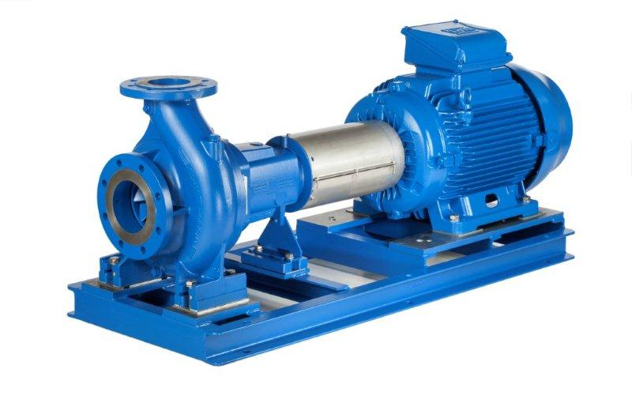

**Figure 11:** Lowara e-NSC end suction pump

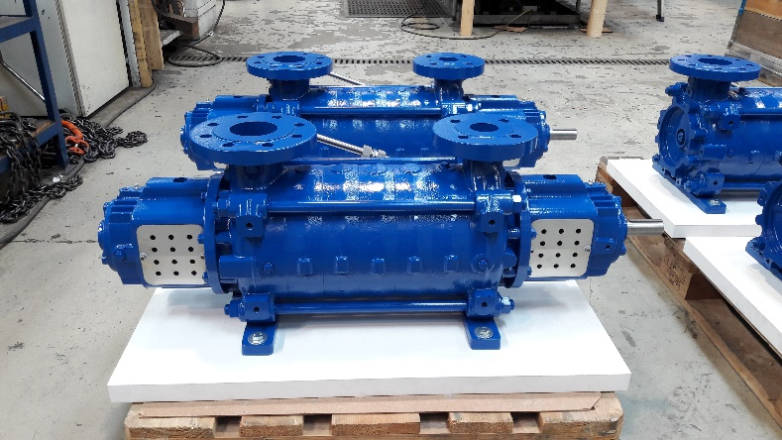

**Figure 12:** Dual bearing pump model

# POC Path to Product

The Xtag serves the key target of establishing functional operation of the full Xtag solution. The following procedure is then performed to obtain the path to manufacturable product result for electronics and system architecture.

**Xtag-B1**

* Omit Motor Sense

**Xtag-B2**

* Omit Particle Argon Module
* Omit Motor Sense
* Omit pressure sense interface
* Omit power management

**Xtag-M**

* Omit Particle Argon Module
* Omit pressure sense interface
* Omit power management

Each module solution will use the provided reference casing and mounting solutions.

# Constraints

Design Requirements

1. Xtag Level 1 unit is equivalent or smaller to the ITT i-ALERT2 monitoring solution
2. Xtag Level 2 has clear illustration and specification for size increases to connectors & features, as available
   1. Shared with team no later than 9/20
3. Connector Specification (IP65)
4. Container Form-Factor and dimension specification (IP65)
5. Internal battery to last 3 years (all models support external power as well)

Design Targets

1. Connectors (small as possible, TV specs met, good combination of all requirements & targets)

# Opens

TDD Development Opens

1. Design compliance confirmation with external VFD by Xylem team
2. Select Reference Pump for PoC design against
3. Validate supply voltage level for RS-485 in Xtag-PoC (3.3V/5V)
4. Validate RS-485 orientation of all connections (e.g. is VFD Follower?)
5. Select Mode of RS-485 (Full Duplex, Half Duplex)

Considerations

1. Customer selection of selected pressure sensor units of desire for future models
2. Evaluation of temperature sensor options (K-type, IR, etc.)
3. Small field probe with vibration and temperature report
4. On-board vibration FFT with real-time processing and external report

# Appendix A – Click, Grove Feature Summary

* Main – [Click Boards - MikroElektronika](https://www.mikroe.com/click), [Seeed Grove Sensor System](http://wiki.seeedstudio.com/Grove/)
* Ref - [MikroElektronika Click Summary](https://www.digikey.com/en/blog/mikroelektronika-mikrobus-click-boards), [Seeed Grove Summary](https://www.digikey.com/en/supplier-centers/s/seeed)

Click boards are available for the following features –

**Comm**

[BLE](https://www.mikroe.com/ble-2-click)

[CAN](https://www.google.com/url?sa=t&rct=j&q=&esrc=s&source=web&cd=1&cad=rja&uact=8&ved=2ahUKEwjr5YztlZPfAhUCxYMKHZpjAKcQFjAAegQICRAB&url=https%3A%2F%2Fwww.mikroe.com%2Fcan-spi-33v-click&usg=AOvVaw0DfSHscFFSPvDQyTQjNTFT)

[LAN](https://www.google.com/url?sa=t&rct=j&q=&esrc=s&source=web&cd=1&cad=rja&uact=8&ved=2ahUKEwiYzvWAlpPfAhUGrYMKHWF2CFIQFjAAegQICRAB&url=https%3A%2F%2Fwww.mikroe.com%2Feth-click&usg=AOvVaw3t7Fg7K9V5iD2zitGfvjGT)

[Fiber Optic I/O](https://www.google.com/url?sa=t&rct=j&q=&esrc=s&source=web&cd=1&cad=rja&uact=8&ved=2ahUKEwjX1dP6lZPfAhUJ2IMKHaSvDUQQFjAAegQICRAB&url=https%3A%2F%2Fwww.mikroe.com%2Ffiber-opt-33v-click&usg=AOvVaw2Hw2zlGRg6cnOBmkOXt1U6)

[GSM](https://www.google.com/url?sa=t&rct=j&q=&esrc=s&source=web&cd=3&cad=rja&uact=8&ved=2ahUKEwj3w9GNlpPfAhUzqoMKHZH8D_EQFjACegQIARAB&url=https%3A%2F%2Fwww.mikroe.com%2Fgsm-4-click&usg=AOvVaw3One-1HMH4YRJYBbiMn1vD)

[LoRa](https://www.google.com/url?sa=t&rct=j&q=&esrc=s&source=web&cd=2&cad=rja&uact=8&ved=2ahUKEwiSlt-HlpPfAhXL64MKHdkbBj8QFjABegQIAhAB&url=https%3A%2F%2Fwww.mikroe.com%2Flora-4-click&usg=AOvVaw1J6ov07xFlZuO3u-DSerBG)

[USB](https://www.google.com/url?sa=t&rct=j&q=&esrc=s&source=web&cd=6&cad=rja&uact=8&ved=2ahUKEwjSsqCWlpPfAhUr5YMKHV1dDWsQFjAFegQICRAB&url=https%3A%2F%2Fwww.mikroe.com%2Fusb-uart-4-click&usg=AOvVaw1OzvRIGilaaJmp3BgtKplW)

[NFC](https://www.google.com/url?sa=t&rct=j&q=&esrc=s&source=web&cd=1&cad=rja&uact=8&ved=2ahUKEwjvqbatlpPfAhVH5oMKHUvPBJwQFjAAegQICRAB&url=https%3A%2F%2Fwww.mikroe.com%2Fnfc-click&usg=AOvVaw1fIzSx6q4tUrZ2Hi5mBbW4)

[RFID](https://www.google.com/url?sa=t&rct=j&q=&esrc=s&source=web&cd=1&cad=rja&uact=8&ved=2ahUKEwjfrMSzlpPfAhXL64MKHdkbBj8QFjAAegQIChAB&url=https%3A%2F%2Fwww.mikroe.com%2Frfid-click&usg=AOvVaw1ORQ-jiHHdc_UeF-UsUfPa)

[RS232](https://www.google.com/url?sa=t&rct=j&q=&esrc=s&source=web&cd=2&cad=rja&uact=8&ved=2ahUKEwjG99a_lpPfAhUC64MKHbb4AswQFjABegQIChAB&url=https%3A%2F%2Fwww.mikroe.com%2Frs232-2-click&usg=AOvVaw21iM6tM0gC042ErI8hXkOA)

[RS485](https://www.google.com/url?sa=t&rct=j&q=&esrc=s&source=web&cd=1&cad=rja&uact=8&ved=2ahUKEwiyx4TGlpPfAhUEo4MKHXuLDSAQFjAAegQICRAB&url=https%3A%2F%2Fwww.mikroe.com%2Frs485-5v-click&usg=AOvVaw2Wg-OWaM_sSTY70Mt-0Jal)

[Wi-Fi](https://www.google.com/url?sa=t&rct=j&q=&esrc=s&source=web&cd=2&cad=rja&uact=8&ved=2ahUKEwj-6qTMlpPfAhVHzIMKHenHDZoQFjABegQIABAB&url=https%3A%2F%2Fwww.mikroe.com%2Fwifi-7-click&usg=AOvVaw0EVnHngy-nFHnUU2IOln-B)

[Zigbee](https://www.google.com/url?sa=t&rct=j&q=&esrc=s&source=web&cd=1&cad=rja&uact=8&ved=2ahUKEwjD5NjSlpPfAhWjj4MKHcAHBZUQFjAAegQICRAB&url=https%3A%2F%2Fwww.mikroe.com%2Fxbee-click&usg=AOvVaw34j16jXKCiQJS-Pnwvh-tD)

[Custom Radio](https://www.mikroe.com/ccrf-2-click)

**User Interface**

[Audio Amplifier](https://www.mikroe.com/audioamp-2-click)

[E-Paper](https://www.google.com/url?sa=t&rct=j&q=&esrc=s&source=web&cd=1&cad=rja&uact=8&ved=2ahUKEwjymNyAl5PfAhXp6YMKHfp-CnkQFjAAegQIChAB&url=https%3A%2F%2Fwww.mikroe.com%2Feink-click&usg=AOvVaw2Bpyuy-rqcTsrXBQ0Z6s8T)

[Joystick](https://www.google.com/url?sa=t&rct=j&q=&esrc=s&source=web&cd=1&cad=rja&uact=8&ved=2ahUKEwiavuqIl5PfAhVJ34MKHaKxANYQFjAAegQIChAB&url=https%3A%2F%2Fwww.mikroe.com%2Fjoystick-click&usg=AOvVaw0zPSK_0awD3bRX76H5WhLJ)

[LCD Display](https://www.google.com/url?sa=t&rct=j&q=&esrc=s&source=web&cd=1&cad=rja&uact=8&ved=2ahUKEwi4xpGOl5PfAhVJ5oMKHXcUA8wQFjAAegQICRAB&url=https%3A%2F%2Fwww.mikroe.com%2Flcd-mini-click&usg=AOvVaw0PPetPbXlXmSZRqR4Bn3fV)

[Microphone](https://www.mikroe.com/mic-click)

[Speech Recognition](https://www.mikroe.com/speakup-2-click)

[MicroSD](https://www.mikroe.com/microsd-click)

[TFT Display](https://www.mikroe.com/riverdi-click)

[Barcode Scanner](https://www.google.com/url?sa=t&rct=j&q=&esrc=s&source=web&cd=1&cad=rja&uact=8&ved=2ahUKEwiG2J6DmJPfAhVM5IMKHdd4CAsQFjAAegQIARAB&url=https%3A%2F%2Fwww.mikroe.com%2Fbarcode-click&usg=AOvVaw1uAnUAEI_zn7eyDVoubdQy)

[MP3](https://www.google.com/url?sa=t&rct=j&q=&esrc=s&source=web&cd=1&cad=rja&uact=8&ved=2ahUKEwjp2O-ImJPfAhVLjoMKHVxVCfMQFjAAegQIChAB&url=https%3A%2F%2Fwww.mikroe.com%2Fmp3-click&usg=AOvVaw1LE-OEUXEq-tfxyrHUWkcD)

**Misc.**

[Stepper Motor Control](https://www.google.com/url?sa=t&rct=j&q=&esrc=s&source=web&cd=5&cad=rja&uact=8&ved=2ahUKEwjl19O1l5PfAhXPpYMKHRwEBXIQFjAEegQIABAB&url=https%3A%2F%2Fwww.mikroe.com%2Fstepper-5-click&usg=AOvVaw2AafkZLleBHZfFZFIcrqvj)

[Servo PWM](https://www.google.com/url?sa=t&rct=j&q=&esrc=s&source=web&cd=1&cad=rja&uact=8&ved=2ahUKEwjvxpC_l5PfAhVhooMKHTYMDisQFjAAegQIBxAB&url=https%3A%2F%2Fwww.mikroe.com%2Fservo-click&usg=AOvVaw0zhBrCqGyVKZk3veSW55L7)

[FLASH](https://www.google.com/url?sa=t&rct=j&q=&esrc=s&source=web&cd=3&cad=rja&uact=8&ved=2ahUKEwjm8KLFl5PfAhUk5oMKHUj2BHwQFjACegQICBAB&url=https%3A%2F%2Fwww.mikroe.com%2Fflash-3-click&usg=AOvVaw3yrYZYiWFgydv9OXPP8Hz4)

[PWM](https://www.google.com/url?sa=t&rct=j&q=&esrc=s&source=web&cd=3&cad=rja&uact=8&ved=2ahUKEwjSxsLNl5PfAhUq7IMKHQwuD_oQFjACegQICBAB&url=https%3A%2F%2Fwww.mikroe.com%2Fpwm-2-click&usg=AOvVaw06mnHBCl45YC9Pfvxw5z61)

[Rotary Encoder](https://www.google.com/url?sa=t&rct=j&q=&esrc=s&source=web&cd=2&cad=rja&uact=8&ved=2ahUKEwio9bWQmJPfAhWX94MKHcjxAPkQFjABegQICBAB&url=https%3A%2F%2Fwww.mikroe.com%2Fopto-encoder-click&usg=AOvVaw3E0xckMsRnAU0zUgwb-k1Q)

**Sense**

[Relative Humidity](https://www.google.com/url?sa=t&rct=j&q=&esrc=s&source=web&cd=1&cad=rja&uact=8&ved=2ahUKEwiaif_PmJPfAhUm2IMKHajOCkMQFjAAegQICRAB&url=https%3A%2F%2Fwww.mikroe.com%2Ftemp-hum-click&usg=AOvVaw2DUOGiFCe8NLpA0YyEoQYL)

[Motion](https://www.google.com/url?sa=t&rct=j&q=&esrc=s&source=web&cd=2&cad=rja&uact=8&ved=2ahUKEwj24PjZmJPfAhWN8oMKHU2aCIAQFjABegQICBAB&url=https%3A%2F%2Fwww.mikroe.com%2F3d-motion-click&usg=AOvVaw3hBIP4JN_FlTXBDGSVksCu)

[CO](https://www.google.com/url?sa=t&rct=j&q=&esrc=s&source=web&cd=1&cad=rja&uact=8&ved=2ahUKEwjsvZTgmJPfAhVG34MKHczRCkUQFjAAegQICRAB&url=https%3A%2F%2Fwww.mikroe.com%2Fco-click&usg=AOvVaw2tdu_Dx9VUidwdlwW2wDPi)/[CO2](https://www.google.com/url?sa=t&rct=j&q=&esrc=s&source=web&cd=1&cad=rja&uact=8&ved=2ahUKEwiKs-XlmJPfAhUqooMKHUgrCoAQFjAAegQICRAB&url=https%3A%2F%2Fwww.mikroe.com%2Fndir-co2-click&usg=AOvVaw3Ipg2C1XOgStSYmxy3LWc1)/[NO2](https://www.google.com/url?sa=t&rct=j&q=&esrc=s&source=web&cd=1&cad=rja&uact=8&ved=2ahUKEwiu56nsmJPfAhUK_4MKHQI4Aq8QFjAAegQIBxAB&url=https%3A%2F%2Fwww.mikroe.com%2Fno2-click&usg=AOvVaw1nLth4mYXdZ14McvNRE4-k)

[Pressure](https://www.google.com/url?sa=t&rct=j&q=&esrc=s&source=web&cd=4&cad=rja&uact=8&ved=2ahUKEwi08M_ymJPfAhXn6oMKHVuqBpAQFjADegQIBxAB&url=https%3A%2F%2Fwww.mikroe.com%2Fpressure-4-click&usg=AOvVaw1tgsl1eeZ8Is3MhiLQoKzQ)

[Temperature](https://www.google.com/url?sa=t&rct=j&q=&esrc=s&source=web&cd=4&cad=rja&uact=8&ved=2ahUKEwjxkOb5mJPfAhWB8oMKHTPbD-QQFjADegQIChAB&url=https%3A%2F%2Fwww.mikroe.com%2Fthermo-4-click&usg=AOvVaw1v1xsLfj18pfFrWiFfODQv)

[Force Sense](https://www.google.com/url?sa=t&rct=j&q=&esrc=s&source=web&cd=1&cad=rja&uact=8&ved=2ahUKEwi_kvi0mpPfAhUn7IMKHQmPDMQQFjAAegQICRAB&url=https%3A%2F%2Fwww.mikroe.com%2Fforce-click&usg=AOvVaw3CTzOs20choCUaL2atm7qG)

[Hall Effect Sense](https://www.google.com/url?sa=t&rct=j&q=&esrc=s&source=web&cd=4&cad=rja&uact=8&ved=2ahUKEwiMrea8mpPfAhVDxYMKHZ1CDFcQFjADegQIBhAB&url=https%3A%2F%2Fwww.mikroe.com%2Fhall-current-2-click&usg=AOvVaw1VBtwJ_3-A9toObyvmh5Rt)

Humidity

Inductance

3D Magnetic Field

Signal Frequency

AC/DC Current

Ambient Light

RF Meter

Water Detect

Velocity

IR Gesture Recognition

Altitude

Digital Pot

Alcohol

Air Quality

Pollution

Ozone

Hydrogen, Methane

VOC

Stretch Sense

GPS

IR Sensor/Transmitter

Resistance

Capacitance

Proximity

Doppler motion detection

Grove modules are available with the following sensors –

[Gas (30+ options)](http://wiki.seeedstudio.com/Sensor_gas/)

[Barometer](https://www.google.com/url?sa=t&rct=j&q=&esrc=s&source=web&cd=1&cad=rja&uact=8&ved=2ahUKEwijnJqlmZPfAhUMr4MKHQJoCAwQFjAAegQICRAB&url=http%3A%2F%2Fwiki.seeedstudio.com%2FGrove-Barometer_Sensor%2F&usg=AOvVaw3Te7U_4SL6S8miiRfOy5be)

[Accelerometer](https://www.google.com/url?sa=t&rct=j&q=&esrc=s&source=web&cd=1&cad=rja&uact=8&ved=2ahUKEwiDwcW8mZPfAhUp5oMKHeX_BYgQFjAAegQICRAB&url=http%3A%2F%2Fwiki.seeedstudio.com%2FGrove-3-Axis_Digital_Accelerometer-1.5g%2F&usg=AOvVaw0d02xwG-X50ORZ3bwXexup)/[Gyro](https://www.google.com/url?sa=t&rct=j&q=&esrc=s&source=web&cd=1&cad=rja&uact=8&ved=2ahUKEwjys4PBmZPfAhXhx4MKHVK7A50QFjAAegQIChAB&url=http%3A%2F%2Fwiki.seeedstudio.com%2FGrove-3-Axis_Digital_Gyro%2F&usg=AOvVaw0QuzNZuh59isfx6efP9Pdt)

[Temperature](https://www.google.com/url?sa=t&rct=j&q=&esrc=s&source=web&cd=1&cad=rja&uact=8&ved=2ahUKEwjcytCrmZPfAhXj4IMKHS9mDuYQFjAAegQIChAB&url=http%3A%2F%2Fwiki.seeedstudio.com%2FGrove-Temperature_Sensor_V1.2%2F&usg=AOvVaw32LoloAouoqzRZfpm643h8) ([Std](https://www.google.com/url?sa=t&rct=j&q=&esrc=s&source=web&cd=1&cad=rja&uact=8&ved=2ahUKEwjcytCrmZPfAhXj4IMKHS9mDuYQFjAAegQIChAB&url=http%3A%2F%2Fwiki.seeedstudio.com%2FGrove-Temperature_Sensor_V1.2%2F&usg=AOvVaw32LoloAouoqzRZfpm643h8)/[High](https://www.google.com/url?sa=t&rct=j&q=&esrc=s&source=web&cd=1&cad=rja&uact=8&ved=2ahUKEwiHnd60mZPfAhVL54MKHdHoAFQQFjAAegQICBAB&url=http%3A%2F%2Fwiki.seeedstudio.com%2FGrove-High_Temperature_Sensor%2F&usg=AOvVaw1f-h7aBoRBweWexAgrk-XV))

[Light](https://www.google.com/url?sa=t&rct=j&q=&esrc=s&source=web&cd=1&cad=rja&uact=8&ved=2ahUKEwjcmt3ImZPfAhXm6IMKHReFAb4QFjAAegQIChAB&url=http%3A%2F%2Fwiki.seeedstudio.com%2FGrove-Light_Sensor%2F&usg=AOvVaw3sDFxzcawwtFVCBfYBjrZ2)/[UV](https://www.google.com/url?sa=t&rct=j&q=&esrc=s&source=web&cd=1&cad=rja&uact=8&ved=2ahUKEwj9xYrOmZPfAhVGwYMKHSp-DEUQFjAAegQICRAB&url=http%3A%2F%2Fwiki.seeedstudio.com%2FGrove-UV_Sensor%2F&usg=AOvVaw2jBPICZY9Z3nYSEkdd0GnD)/[Color](https://www.google.com/url?sa=t&rct=j&q=&esrc=s&source=web&cd=1&cad=rja&uact=8&ved=2ahUKEwjxrp3TmZPfAhWppYMKHbg_CEAQFjAAegQIChAB&url=http%3A%2F%2Fwiki.seeedstudio.com%2FGrove-I2C_Color_Sensor%2F&usg=AOvVaw1A4BRptKmJHuvA28dNT_vs)

[Sound](https://www.google.com/url?sa=t&rct=j&q=&esrc=s&source=web&cd=2&cad=rja&uact=8&ved=2ahUKEwiD97nYmZPfAhUFzoMKHQb4BFoQFjABegQIABAB&url=https%3A%2F%2Fwww.seeedstudio.com%2FGrove-Sound-Sensor-p-752.html&usg=AOvVaw0ZcVtIaDxAX9oc4GpOQeSD)/[Loudness](https://www.google.com/url?sa=t&rct=j&q=&esrc=s&source=web&cd=1&cad=rja&uact=8&ved=2ahUKEwjK-aDdmZPfAhVjxYMKHRQJDxIQFjAAegQIChAB&url=http%3A%2F%2Fwiki.seeedstudio.com%2FGrove-Loudness_Sensor%2F&usg=AOvVaw1Ezo3eLWFNiWG4d26NHK2q)

[Distance](https://www.google.com/url?sa=t&rct=j&q=&esrc=s&source=web&cd=3&cad=rja&uact=8&ved=2ahUKEwiks9XhmZPfAhXho4MKHXGNCH4QFjACegQICBAB&url=http%3A%2F%2Fwiki.seeedstudio.com%2FGrove-80cm_Infrared_Proximity_Sensor%2F&usg=AOvVaw3W033b0StJKrp_2Kjvyrpc)

[Magnetic Field](https://www.google.com/url?sa=t&rct=j&q=&esrc=s&source=web&cd=2&cad=rja&uact=8&ved=2ahUKEwin6Jz0mZPfAhXGpYMKHSmeAdMQFjABegQICBAB&url=http%3A%2F%2Fwiki.seeedstudio.com%2FGrove-2_Channel_Inductive_Sensor-LDC1612%2F&usg=AOvVaw0GSmJf4uAmUDueIwftI6ML)

[Compass](https://www.google.com/url?sa=t&rct=j&q=&esrc=s&source=web&cd=1&cad=rja&uact=8&ved=2ahUKEwj0_Y7_mZPfAhUGpoMKHRyZC0cQFjAAegQIARAB&url=https%3A%2F%2Fwww.seeedstudio.com%2FGrove-3-Axis-Digital-Compass-p-759.html&usg=AOvVaw2PQtnPbW7Nhpt-HoSQfceo)

[PIR](https://www.google.com/url?sa=t&rct=j&q=&esrc=s&source=web&cd=1&cad=rja&uact=8&ved=2ahUKEwim4IKFmpPfAhXzoIMKHRHIC-MQFjAAegQICRAB&url=http%3A%2F%2Fwiki.seeedstudio.com%2FGrove-PIR_Motion_Sensor%2F&usg=AOvVaw13e7qMV03ezQd7dXV7vqKd)

[Air Quality](https://www.google.com/url?sa=t&rct=j&q=&esrc=s&source=web&cd=1&cad=rja&uact=8&ved=2ahUKEwjBr8mKmpPfAhXk7oMKHeBDBYoQFjAAegQICRAB&url=http%3A%2F%2Fwiki.seeedstudio.com%2FGrove-Air_Quality_Sensor_v1.3%2F&usg=AOvVaw2eFDxFR8uuEbRIT4NdTTLW)

[Alcohol](https://www.google.com/url?sa=t&rct=j&q=&esrc=s&source=web&cd=1&cad=rja&uact=8&ved=2ahUKEwiDhcCampPfAhXi44MKHSLuAD4QFjAAegQICRAB&url=http%3A%2F%2Fwiki.seeedstudio.com%2FGrove-Alcohol_Sensor%2F&usg=AOvVaw25tNmZ7ri304Prsa_hOwhU)

[Proximity](https://www.google.com/url?sa=t&rct=j&q=&esrc=s&source=web&cd=1&cad=rja&uact=8&ved=2ahUKEwi9052UmpPfAhVI7oMKHfzwD_8QFjAAegQIChAB&url=http%3A%2F%2Fwiki.seeedstudio.com%2FGrove-80cm_Infrared_Proximity_Sensor%2F&usg=AOvVaw3W033b0StJKrp_2Kjvyrpc)

[Dust](https://www.google.com/url?sa=t&rct=j&q=&esrc=s&source=web&cd=1&cad=rja&uact=8&ved=2ahUKEwiR14KimpPfAhUL9YMKHetiAqsQFjAAegQICRAB&url=http%3A%2F%2Fwiki.seeedstudio.com%2FGrove-Dust_Sensor%2F&usg=AOvVaw1HbedSiW077isxCW0wC2p0)

[Moisture](https://www.google.com/url?sa=t&rct=j&q=&esrc=s&source=web&cd=1&cad=rja&uact=8&ved=2ahUKEwjj5M6nmpPfAhWb94MKHdmwCB4QFjAAegQICRAB&url=http%3A%2F%2Fwiki.seeedstudio.com%2FGrove-Moisture_Sensor%2F&usg=AOvVaw0F1F79qgGSQVz9usPF5GG-)

[Vibration](https://www.google.com/url?sa=t&rct=j&q=&esrc=s&source=web&cd=1&cad=rja&uact=8&ved=2ahUKEwiCtqWtmpPfAhVr_IMKHS92DCkQFjAAegQICRAB&url=http%3A%2F%2Fwiki.seeedstudio.com%2FGrove-Piezo_Vibration_Sensor%2F&usg=AOvVaw3sajcSlMI9fHXk1X7EfTS3)

Time of Flight

Motor drivers

All common radios (e.g. Click list above

# References

[1] Suppl/Power Budget/XtagPowerBudgetCalcs.m

[2] <http://www.energizer.com/specialty-batteries/2450-battery>

[3] [TI SLUSAN2C – TI BQ24130, 600-kHz Switch-Mode Battery Charger With 4-A Integrated MOSFETs](https://www.google.com/url?sa=t&rct=j&q=&esrc=s&source=web&cd=1&cad=rja&uact=8&ved=2ahUKEwjHyrS41dneAhUIXK0KHSycCJ8QFjAAegQICBAC&url=http%3A%2F%2Fwww.ti.com%2Flit%2Fds%2Fsymlink%2Fbq24130.pdf&usg=AOvVaw0YqYQ0jW8Pfzk1l3tYuFfF)

**Vocabulary**

* Follower – Description for ‘Slave’ unit of communications interface

# Notes

1. Currently in evaluation with Texas Instruments DRV425 ([ref](http://www.ti.com/product/DRV425?keyMatch=DRV425RTJT&tisearch=Search-EN-Everything))
2. When notation ‘Xtag’ is used without suffix then ‘Xtag-B1’ is assumed
3. Xylem sets new VFD models to Follower RS-485 configuration (email 10/2)
4. In idle the LED will flash momentarily, with a configurable rate initialized every 5 seconds
5. Argon Supplied